Homework 4: Due Date: 07/11/2022

* 1. Write a recursive program to find the sum of first n numbers.

sum = 1 +2 + 3 + …….n

* 1. Given a string, check whether the string is a palindrome or not . Write the recursive function. The function will return true or false
  2. Given a integer number, check whether it is palindrome or not. Write recursive function. It will return true or false
  3. Given two integers, find and print the GCD (Greatest Common Divisor) of them. The function will return the GCD
  4. Reverse a string using Recursion
  5. Change the print_all function of a linked list to print all the value of nodes recursively
  6. Delete the first kNodes in a linked list using Recursion
  7. This problem is about generating Power set in lexicographical order.  **Examples :**
     + **Input :** abc
     + **Output :** a ab abc ac b bc c
  8. Given a linked list, print alternate nodes of this linked list.

Examples :

Input : 1 -> 2 -> 3 -> 4 -> 5 -> 6 -> 7 -> 8 -> 9 -> 10

Output : 1 -> 3 -> 5 -> 7 -> 9

Input : 10 -> 9

Output : 10

* 1. Given a doubly linked list. Reverse it using recursion. Here we assume, we keep self.head pointer. We are not keeping self.tail.

Given Linked List:

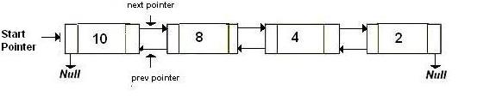

Reversed Linked List:

* 1. Write a recursive function minRec(arr, n) to find the minimum element of an array. **arr** is the array and n is the length of the arr.
  2. Determine whether a string matches with a given pattern

Given a string and a pattern, determine whether a string matches with a given pattern. The solution should not use any **regex.**

For example,

Input:  
   
string: codesleepcode  
pattern: XYX  
   
Output:  
X: code  
Y: sleep  
   
   
Input:  
   
string: codecodecode  
pattern: XXX  
   
Output:  
X: code